SHORT TERM DOCUMENT OF COMPLIANCE


Issued under the provisions of the International Convention for the Safety of Life at sea, 1974,
As amended under the authority of the Government of
THE MERCHANT MARINE HONDURAS
By GR CLASS CLASSIFIED FOR STANDARD (GR CLASS)

DOC No.

Name and Address of the Company
(see paragraph 1.1.2 of the ISM Code)

Company Identification Number1

THIS IS TO CERTIFY THAT the safety management system of the Company has been Recognized as a meeting objectives of paragraph
1.2.3 of the International Management Code for the safe Operation of Ships and for Pollution Prevention (ISM Code) for the type(s) of ships listed below (Select as appropriate):

Passenger Ship
Passenger High-speed Craft Cargo High-speed Craft
Bulk Carrier Oil Tanker
Chemical Tanker Gas Carrier
Mobile Offshore Drilling Unit Other Cargo Ship

This Document of Compliance is valid until
(DD-MM-YYYY)

Issued at Date of issue
(Place of issue of certificate) (DD-MM-YYYY)

GR CLASS REPRESENTATIVE

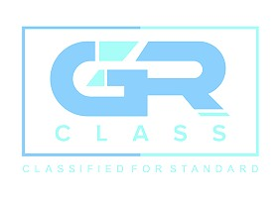

1

GR CLASS – CLASSIFIED FOR STANDARD (GR CLASS)

E-mail: info@grclass.com Web: www.grclass.com

Form DOC-ST Approved by: GM Page 1 of 1

